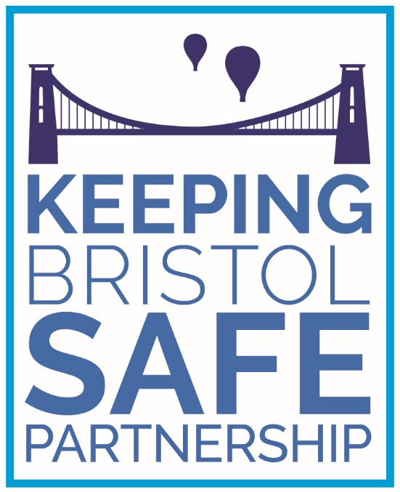

Terms of Reference for Keeping Children Safe Board

June 2024
Version Control

Version | Date | Reviewer | Change Made
V1 | 18.10.19 | Interim PPO | Document Created
V2 | 13.11.19 | Interim PPO | Changes, amendments post KCS discussion
V3 | 18.12.19 | KBSP KCS | Changes, amendments post KCS discussion
V4 | 27.02.20 | KBSP BU | Amendment to meeting frequency
V5 | 23.08.2022 | KBSP BU | Updated, including membership
V6 | 03.11.2022 | KBSP BU | Updated, including membership
V7 | 24-5-2024 | KBSP BU OK | Update for Governance compliancy

Keeping Children Safe Terms of Reference
The Keeping Children Safe Board is a multi-agency group who agree how the relevant organisations cooperate to safeguard and promote the welfare of children, to hold each other to account and ensure that safeguarding children remains high on the agenda across the partnership area. The board shares emerging themes into the Keeping Bristol Safe Partnership (KBSP) Steering Group.

The Group will work in association with the Safeguarding Adult Board (Keeping Adults Safe) and Community Safety Partnership (Keeping Communities Safe) as well as Young People Groups, as appropriate, to deliver shared priorities. The Group will ensure that the impact of the collective actions on the child is at the centre of what they do.

The Group will be known as Keeping Children Safe.

Objectives
The Keeping Children Safe Group, which will:

- Ensure that partners in Bristol work together, to safeguard and promote the welfare of Children in Bristol as set out in Multi Agency Statutory Guidance.

- Ensure single agency and partnership work to protect the safety of Children is coordinated and effective and have a shared focus on early intervention, prevention and commissioning as outlined in Section 14 of the Children’s Act 2004.

- Drive continuous improvement in outcomes to reduce risk of harm to Children in Bristol through improved quality and performance across the partnership informed by quality and assurance activities.

- Use their expertise to understand and oversee new initiatives, innovations or commissioning programmes in a context of improving outcomes for all Children at risk in Bristol.

- Develop a culture of best practices and sharing of success stories.

Roles and Responsibilities
- Undertake a Strategic Child Safeguarding Needs Assessment and identify key Children Safeguarding Priorities for Bristol.

- Maintain the Action Plan for the KBSP Strategic Plan (2023-2026), based on identified Child Safeguarding priorities and respond to relevant actions / activity.

- Keeping Children Safe is responsible for final quality assurance and sign off of CSPRs before they are sent to National Panel. This includes acceptance of action plans for the agency that the attendee represents.

- Supply a Children Safeguarding submission setting out progress in relation to the Business Plan and other work for inclusion in the annual report.

- Work to develop a data dashboard for KCS group and ensure the submission of multi-agency data is presented by core partners in relation to children and young people across the city.

- Review quality assurance work to ensure continuing developments of safeguarding children practice in Bristol.

- Develop and deliver against the appropriate actions from national and local reviews including, child practice reviews, safeguarding adult reviews, and domestic homicide reviews.

- Promote best practice across the KBSP safeguarding boards and actively seek ways to share learning.

- Ensure that agencies meet their responsibilities and arrangements for Section 11 audit requirements.

- All members to commit organisational resources for task and finish groups to deliver against the board’s strategic priorities.

- Sign off amendments and revisions to multi agency policy and procedures.

Task and Finish Groups
- Task and Finish Groups are short-life groups set up to deliver a certain project or piece of work, for example undertake a multi-agency audit or commission a new training programme. To support a dynamic approach to prompt delivery of output from these tasks and finish groups the aim will be to keep numbers low. A suggested maximum membership is around 10 members who meet around 4 times in a relatively short time frame to deliver a prompt output.

- The Business Unit will advertise these groups across the partnership to ensure wide engagement and opportunities for contribution from sector experts and participation groups across the city. Members of the Group or Board will nominate contributors from their agency.

- The task and finish group chair will be appointed after volunteering or being nominated by their agency and is responsible for establishing commitment from members at outset to ensure and agreeing the timetable of meetings.

Sector Specific Representation
- Where appropriate, sector specific subject matter experts will be invited to Keeping Children Safe meetings, to take part in Task and Finish groups, or to produce output on behalf of the Group. This work will be coordinated by a nominated member on behalf of Keeping Children Safe.

- Representatives of Sector specific groups are responsible for ensuring dissemination (sharing relevant papers before the meeting), engagement and resourcing across the sector.

Accountability and Reporting
- It is the responsibility of the Group’s members to report into and out of other relevant Groups within their agency to ensure information sharing, shared ownership of performance indicators, actively challenge silo working and to support the Group to identify synergies across the partnership.

Administration and Membership
- Meetings will take place bi-monthly; 2 hours in duration.

- Papers will be issued 1 week prior to the meeting following an Agenda setting meeting between the Chair and KBSP Business Unit.

- Requests for items to be placed on the agenda should be submitted to the KBSP@bristol.gov.uk at least 2 weeks before the meeting is due to take place.

- Additional extra-ordinary meetings may also be scheduled to undertake specific pieces of work.

- Business support will be provided by the Keeping Bristol Safe Partnership Business Unit. Enquiries regarding the group should be sent to KBSP@bristol.gov.uk.

- A meeting must be attended by representatives from at least three of the statutory agencies (not including the KBSP BU) in order to be considered quorate. The three statutory agencies being Avon and Somerset Police, BNSSG ICB and Bristol City Council.

- Members are representatives of their organisation who have strategic roles in relation to safeguarding and promoting the welfare of children within their organisation.

- If a member is not able to attend, then they will arrange for a deputy to attend in their absence and they should have the ability to contribute to the decisions made by the group.

Current membership of the delivery group is as follows:
Role | Agency
Executive Director of Children and Education (Chair) | Bristol City Council
Strategic Safeguarding and Quality Assurance Service Manager (Deputy Chair) | Bristol City Council
Director of Nursing | BNSSG ICB
Chief Superintendent | Avon and Somerset Constabulary
Director of Education and Skills | Bristol City Council: Education
Director of Adult Social Care | Bristol City Council: Adult Social Care
Designated Nurse for Safeguarding Children | BNSSG ICB
Head of Children’s Services | Sirona (Community health children’s services)
Safeguarding lead for children | Sirona (Community health children’s services)
Safeguarding lead for children | Avon & Wiltshire Partnership
Manager/Director | Bristol City Council – Housing and Landlord Services
Manager | Creative Youth Network
Community Safety Manager | Bristol City Council: CSP/Safer Communities
Public Health Consultant / Specialist | Bristol City Council – Public Health
Education Director | | Cabot Learning Federation
Head Teacher | Bristol City Council – Virtual Hope School
Business Manager | Keeping Bristol Safe Partnership
Business Unit | Keeping Bristol Safe Partnership
Associate Director of Safeguarding | North Bristol NHS Trust
Associate Director of Safeguarding | University Hospitals Bristol and Weston NHS Foundation Trust
Head of Safeguarding, Nursing and Quality | Avon and Wiltshire Mental Health Partnership NHS Trust
Social work lead for drugs and alcohol services | Avon and Wiltshire Mental Health Partnership NHS Trust
Safeguarding lead | Avon Fire and Rescue
Senior Probation Officer | Probation Service – Bristol Unit
Manager | Youth Offending service
Head of Childrens Placement Services | Bristol City Council
CEO | 1625 Independent People
Assistant Director | Barnardo’s
Senior Manager | Spire Healthcare
Clinical Lead | The Green House
Supporting Families Employment Adviser | Department of Work and Pensions
Chief Executive | Learning Partnership West (LPW)

Members are expected to:
- Have sufficient authority within their organisation to make decisions in relation to the work of the group. This is of particular importance where reviews are quality assured as they may contain findings of relevance to the member’s agency.

- Attend extra-ordinary meetings which may be set at short notice and should be prioritised as far as possible.

- Act as an information conduit between the delivery group and to the senior management teams in their own agencies, ensuring that areas of concern are brought to immediate attention. Members should also be aware of the highly sensitive nature of the subjects discussed within the delivery group and ensure their communications and data storage is secure.

- Undertake attributed work/actions as appropriate to their roles on behalf of the group.

- Prioritise attendance to all in-person and online meetings. Where this is not possible, send an appropriate delegate who has been briefed on the role.

- Read all papers shared in advance of the meeting and have sought clarification where required.

Decision Making
- Decision making will be arrived at by consensus of the members with a casting vote by the Chair.

The current chair of the Keeping Children Safe Delivery Group is the Executive Director for Children and Education in Bristol City Council, and the role of deputy chair is the Strategic Safeguarding and Quality Assurance Service Manager for Bristol City Council Children’s Services.

Review Schedule
Terms of Reference will be reviewed annually.
These TOR were formally adopted in May 2024 and are scheduled for review in May 2025

Declaration
I have read the above Terms of Reference and understand my role as a member of the Keeping Children Safe Delivery Group.
Name:

Role:

Agency:

Date:

