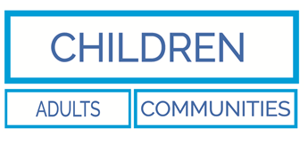
Resolution of Professional
Disagreements in work relating
to the safety of children

A tool to record decisions and to monitor the effectiveness of the professional differences policy
(Please use in conjunction with the KCS and SW procedure ‘resolving professional differences procedure’ - http://www.swcpp.org.uk/swcpp/swcpp_procedures.htm)
Experience and outcomes of serious case reviews tells us how devastating professional disagreements can be to children. When concerns are raised but not addressed or when services are requested but not provided. Without an effective means to address concerns issues escalate, relationships between partner agencies deteriorate, problems drag on for weeks, months and years and, in the worse cases, children do not receive adequate services and are left exposed to harm.
This tool is a means to enable your service to record the agreed outcome of the use of the professional differences policy, and to aid KCS to monitor its use.
This form to be used at stage three and at each subsequent stage of the professional’s disagreements policy.
Child/Family name:

Summary of reason for dispute – include views of all agencies concerned.

Agreed outcomes or actions if satisfactorily resolved – includes escalation to next stage if unresolved

Action Note:
Copy of this form to be held on child/family file in all agencies involved in resolution of professional difference, if escalating to next stage use as basis of report to manager at next stage, send copy to your approved resolution audit manager or the LSCB for monitoring purposes.
Signature of challenger manager | Name:
 | Designation:
 | Agency:
 | Date:
Signature of challenged manager | Name:
 | Designation:
 | Agency:
 | Date:

Please complete for monitoring purposes

Stage at which resolution achieved-  3 4 5 | Time taken to reach resolution-  (no. of Days) | Please note how effective this policy was in resolving the issue and please make suggestions as to how the policy can be improved:
Additional Notes:

